CMIS 320 – Project 4

Nabeel Hussain

University of Maryland, University College

CMIS 320

July 13th, 2017

1. Yes, the relation given seems to be in at least 1NF, because the value of each attribute contains only a single value from that domain. There are no cells which contain multiple values in them and every attribute of the table is unique.
2. Since the relation does not contain one specific primary key with unique values, we will need to create a composite primary key where more than one column is used to specify the **primary key** of the relation table. I would suggest the primary key to be the combination of (GIRL, AGE, GAME), as this uniquely identifies all the other columns as well, maintaining the unique record.
3. If we delete the tuple containing Jacqueline, then there will be a loss of some attribute data such as GAME Visual Basic and CATEGORY Prog. Languages.

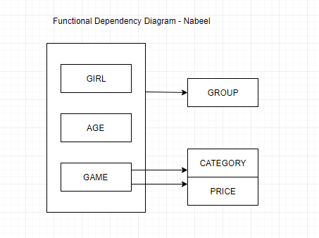

1. The relation of (GIRL, GROUP, AGE, GAME, CATEGORY, PRICE) and **primary key** (GIRL, AGE, GAME) is in **1NF** form. Since it has partial dependencies it cannot be 2NF or 3NF.
2. For a relation to be 3NF, it needs to be 2NF with no transitive dependencies. Thus, we need to convert the relation into 2NF before we put it to 3NF in relational notation.

In the initial relation, we can infer that the CATEGORY and PRICE is determined by the GAME name, so we need to separate the relation table with those attributes.

GIRL (GIRL, GROUP, AGE, GAME)

GAME (GAME, CATEGORY, PRICE)

**GIRL**

|  |  |  |  |
| --- | --- | --- | --- |
| GIRL | GROUP | AGE | GAME |
| Charlotte | 5 year olds | 5 | Mirror |
| Susan | 6 year olds | 6 | Lipstick |
| Jane | 5 year olds | 5 | Chess |
| Susan | 6 year olds | 6 | Checker |
| Susan | 6 year olds | 6 | Mirror |
| Carrie | 6 year olds | 6 | Lipstick |
| Jacqueline | 5 year olds | 5 | Visual Basic |

**GAME**

|  |  |  |
| --- | --- | --- |
| GAME | CATEGORY | PRICE |
| Mirror | Makeup | 4.88 |
| Lipstick | Makeup | 5.98 |
| Chess | Game | 7.55 |
| Checker | Game | 5.95 |
| Visual Basic | Prog. Languages | 199.9 |

After eliminating the transitive dependencies in the 2NF and to convert to 3NF we get:

Girl (GIRL, AGE, GAME)

AgeGroup (AGE, GROUP)

Game (GAME, CATEGORY, PRICE)

3

There are relations in 3NF

**Girl**

|  |  |  |
| --- | --- | --- |
| GIRL | AGE | GAME |
| Charlotte | 5 | Mirror |
| Susan | 6 | Lipstick |
| Jane | 5 | Chess |
| Susan | 6 | Checker |
| Susan | 6 | Mirror |
| Carrie | 6 | Lipstick |
| Jacqueline | 5 | Visual Basic |

**AgeGroup**

|  |  |
| --- | --- |
| AGE | GROUP |
| 5 | 5 years old |
| 6 | 6 years old |

**Game**

|  |  |  |
| --- | --- | --- |
| GAME | CATEGORY | PRICE |
| Mirror | Makeup | 4.88 |
| Lipstick | Makeup | 5.98 |
| Chess | Game | 7.55 |
| Checker | Game | 5.95 |
| Visual Basic | Prog. Languages | 199.9 |